Bus Planning System

TABLE OF CONTENTS

PREFACE ……………………………………………………………………………………… 1

***PART ONE – INTRODUCTION***

**CHAPTER 1 – GETTING STARTED**

Using the Application ……………………………………………………………….…….…… 5

***PART TWO – CITY SYSTEM***

**CHAPTER 2 – CITY STATION DATABASE**

What is the City Station Database? ……………………………………………………………. 11

Displaying the Entire City Station Database Listing …………………………………………. 12

**CHAPTER 3 – CITY ROUTE PLANNING**

What is a City Route Plan? ……………………………………….……………………………. 14

Creating a City Route Plan ……………………………………….……………………………. 14

Understanding Your City Route Plan ……………………………………….…………………. 15

***PART THREE – NATIONAL SYSTEM***

**CHAPTER 4 – THE NATIONAL STATION DATABASE**

What is the National Station Database? ……………………………………………………….. 17

Adding and Deleting Stations …………………………………………………………….......... 17

Adding and Deleting Connections ………………………………………………………….…. 18

Displaying the Entire National Station Database Listing ……………………………………… 19

**CHAPTER 5 – THE BUS DATABASE**

What is the Bus Database? ……………………………………….……………………..…..….. 21

Adding and Deleting Buses ……………………………………….……………………………. 21

Displaying the Entire Bus Database Listing …………………………………….……………… 22

**CHAPTER 6 – NATIONAL ROUTE PLANNING**

What is a National Route Plan? ……………………………………….………………………… 24

Creating a National Route Plan ……………………………………….………………………… 24

Understanding Your National Route Plan……………………………………….……………… 26

**APPENDIX**

Sample Buses and Bus Stations ……………………………………….……………...………... 27

**GLOSSARY**

Terminology Definitions ……………………………………….……………...………............... 28

Preface

***What is the Bus Planning System Program?***

The Bus Planning System (BP) is an application with the primary purpose of generating the most efficient routes between two user-selected bus stations. In the National Bus Routing System, bus information including the name, gas tank size, cruise consumption, and cruise speed is made available to the user when generating a route. The application also provides the user with bus station information, such as the name, type, *latitude*, and *longitude*. Additionally, when the routes are generated, the application presents the user with the leg number, starting location, destination, and, in the case of the National Bus Routing System, cruising gas consumption and cruising speed.

***Who Should Use This Program?***

The primary users of this application are intended to be those who have an interest in all the considerations that must be made when generating a bus route between two stations. When compared to similar route planners that are actively used in the real world, BP represents a simpler version of this type of travel planner, making it perfect for students looking to learn the intricacies of a travel system while not being overwhelmed with unfamiliar details. Due to the simplified nature of this application, it should only be used as an educational resource. It does not act as a substitute for other travel planners. More details on this can be found in Chapter 1.

***Organization of this User Manual***

This manual is divided into three parts, an appendix, and a glossary. Part One includes Chapter 1 and acts as an information section on how to use BP. Part Two includes Chapter 2 and Chapter 3 and explains how to make use of the city routing function of BP. Part Three includes Chapter 4, Chapter 5, and Chapter 6 and provides specific, in-depth details of the major systems utilized in the national routing function of BP. The appendix and glossary can be found at the end of the manual containing sample data and definitions, respectively. Following are more detailed descriptions of each chapter:

Chapter 1 – Getting Started:

Provides a brief instruction on how to utilize BP as well as additional information on what the application does.

Chapter 2 – City Station Database:

Provides additional information on the City Station *database* used in BP. This *database* contains all details related to the use of city bus stations by the application. This chapter will help you better understand the functionality of the *database*.

Chapter 3 – City Route Planning:

Provides you with a brief information section on what a city route plan is, how it is implemented into BP, and how you can create your own route plan using existing stations. Additional instruction is provided on how to interpret the route plan generated by the application.

Chapter 4 – The National Station Database:

Provides information on the National Station Database used in BP. This *database* contains all necessary details related to the usage of national bus stations and gas stations by the application. This chapter will show you how to add delete existing stations as well as how to create manage between them.

Chapter 5 – The Bus Database:

Provides information on the Bus Database used in the function of BP. This *database* contains all details necessary to the usage of buses by the application. This chapter will show you how to add buses to your *database*, as well as how to delete existing buses.

Chapter 6 – National Route Planning:

Provides you with a brief information section on what a national route plan is, how it is implemented into BP, and how you can create your own route plan using existing stations or your own. Additional instruction is provided on how to interpret the route plan generated by the application.

Appendix:

Contains sample bus and bus station data that you can use as test input within BP.

Glossary:

Contains definitions for certain terminology.

***Conventions Used Within this Manual***

Following is a list of explanations for each of the special conventions used to highlight specific contents of this manual.

**Bold** – Indicates menu choices that a user can select at runtime.

*Italic* – Indicates terms that can be found in the Glossary at the end of the manual.

Underline – Indicates Chapter and section headings found within this manual.

***Comments and Questions***

To report a bug or learn more about BP, please contact us via email at one of the following addresses:

Joseph Taylor [josephrt@usca.edu](mailto:josephrt@usca.edu)

Jeffrey Lipford [jlipford@usca.edu](mailto:jlipford@usca.edu)

Drake Jones [dajones@usca.edu](mailto:dajones@usca.edu)

Chapter 1

Getting Started

**Using the Application**

**System Requirements**

BP was built within the *Java* v1.8 programming environment in *Eclipse* build 4.9 for use on the University of South Carolina – Aiken. For this reason, it is recommended to run the application on a device with at least the *Java* v1.8 *runtime environment* installed to avoid any potential issues in functionality. To download the latest version of the *Java* *runtime environment*, visit [www.java.com](http://www.java.com) and locate the appropriate version.

Since BP relies on a graphical user *interface*, the primary requirement is a version of the *Java runtime environment*. As long has to user can run the command line and locate the source folder of the program, they are able to run the application provided they have an appropriate environment.

**How Do I Run the Bus Planning System?**

After the *Java* *runtime environment* has been installed on your device, it will be possible to run BP. Simply open your Command Prompt, change the directory to the folder containing BusStationMain.java, then type the following:

java BusStationMain

If the application runs successfully you will see the following screen:

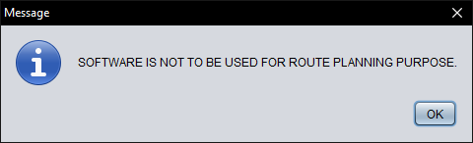

Press **OK** to be taken to a new window:

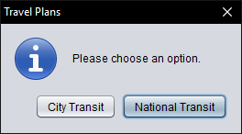

These options will take you to either of the two major functionalities within BP. Selecting **City Transit** will display the following window:

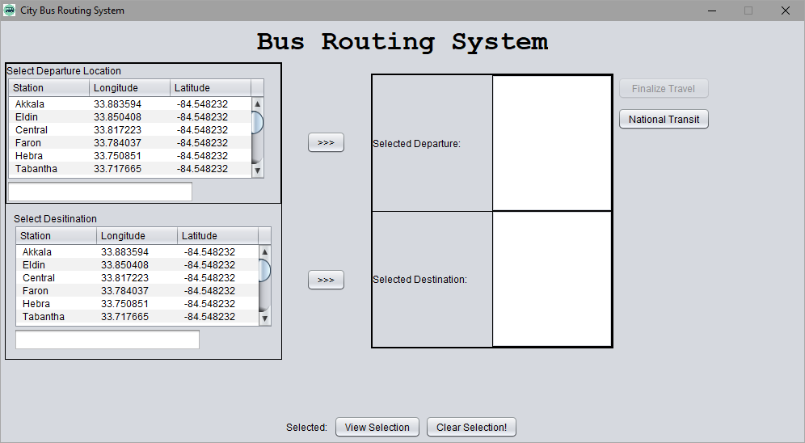

Following is the purpose of each section of the City Bus Routing System:

**1. Select Departure Location**

This section contains the list of bus stations contained in the City Station Database. You can search for and select the bus station you would like to travel from on your route. The details of the selected station appear in the Selected Departure section to the right when you click the **“>>>”** button. More information on this functionality can be found in Chapter 3 where city route planning is covered in more detail.

**2. Select Destination**

This section contains the list of bus stations contained in the City Station Database. You can search for and select the bus station you would like to travel to on your route. The details of the selected station appear in the “Selected Destination” section to the right when you click the **“>>>”** button. More information on this functionality can be found in Chapter 3 where city route planning is covered in more detail.

**3. Finalize Travel**

This option is made available when a starting station and a destination have been selected. Selecting it brings up three potential routes that can be viewed and selected by clicking on the buttons that represent the different routes. More information on this functionality can be found in Chapter 3 where city route planning is covered in more detail.

**4. View Selection**

This option allows you to view a selected route after choosing it in the **Finalize Travel** option. More information on this functionality can be found in Chapter 3 where city route planning is covered in more detail.

**5. Clear Selection**

This option allows you to clear a selected route after choosing it in the **Finalize Travel** option. More information on this functionality can be found in Chapter 3 where city route planning is covered in more detail.

**6: National Transit**

This option redirects the user to the National Bus Routing System, where they can find a similar route nationally rather than in a default city. This option is not necessary to the functionality of the City Bus Routing System.

Selecting **National Transit** in the original option window will display the following window:

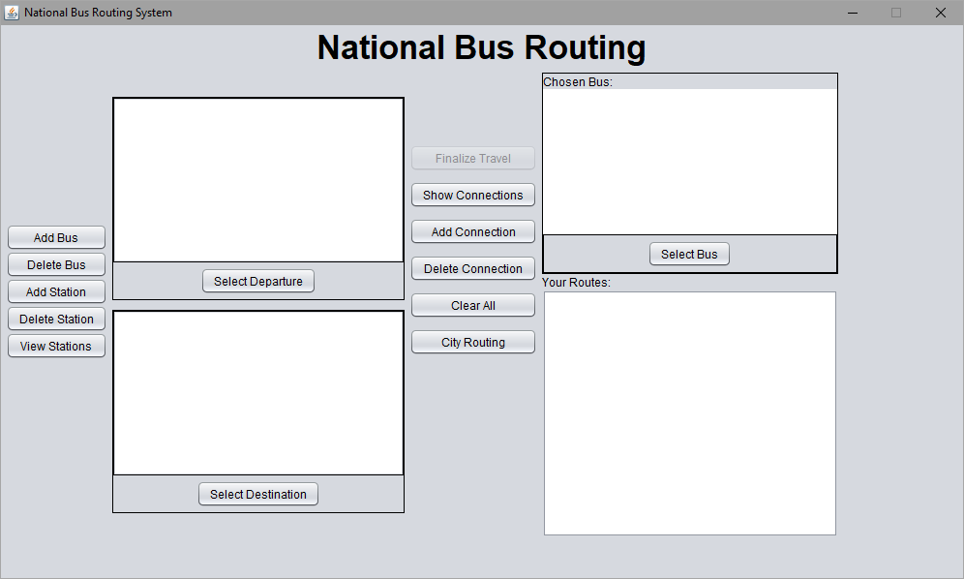

Following is the purpose of each section of the National Bus Routing System:

**1. Select Bus**

This option brings up the list of buses in the Bus *database*. You can search for and select the bus you would like to use on your route. The details of the selected bus appear in the main *interface* in the “Chosen Bus” section. More information on this functionality can be found in Chapter 6 where route planning is covered in more detail.

**2. Add Bus**

This option allows you to create a bus and add it to the *database*. You can input the Make and Model, Tank Size, Cruising Consumption, and Cruising Speed of the bus. More information on this functionality can be found in Chapter 5, where it and the Bus Database are covered in more detail.

**3. Delete Bus**

This option brings up to list of buses in the *database*. It allows you to delete a specific bus from the *database*. You can search for the bus you would like to delete. More information on this functionality can be found in Chapter 5, where it and the Bus Database are covered in more detail.

**4. Add Station**

This option allows you to create a station and add it to the National Station Database. You can input the Station Name, the Type of station, the Longitude, and Latitude. More information on this functionality can be found in Chapter 4, where it and the National Station Database are covered in more detail.

**5. Delete Station**

This option brings up a list of Bus Stations in the National Station Database. It allows you to delete a specified bus station from the *database*. You can search for the station you would like to delete. More information on this functionality can be found in Chapter 4, where it and the National Station Database are covered in more detail.

**6. View Stations**

This option simply allows you to view a list of Bus Stations in the National Station Database.

**7. Select Departure**

This option brings up a list of Bus Stations in the *database*. It allows you to search for and select the bus station you would like to act as the starting station of your generated route. The details of the selected bus station appear in the main *interface* in the area above the **Select Departure** button. More information on this functionality can be found in Chapter 6, where national route planning is covered in more detail.

**8. Select Destination**

This option brings up a list of Bus Stations in the *database*. It allows you to search for and select the bus station you would like to act as the ending station of your generated route. The details of the selected bus station appear in the main *interface* in the area above the **Select Destination** button. More information on this functionality can be found in Chapter 6, where national route planning is covered in more detail.

**9. Show Connections**

This option displays a list of the connections between Bus Stations in the *database*. This option is what allows you to view which stations are connected to each other when a route is generated. More information on this functionality can be found in Chapter 6, where national route planning is covered in more detail.

**10. Add Connection**

This option connects the selected departure and destination bus stations. This enables you to establish new route connections between existing stations or new ones you create. More information on this functionality can be found in Chapter 6, where national route planning is covered in more detail.

**11. Delete Connection**

This option disconnects the selected departure and destination bus stations. This enables you to remove route connections between existing stations or new ones you create. More information on this functionality can be found in Chapter 6, where national route planning is covered in more detail.

**12. Clear All**

This option clears all selections the user has made, including the starting station, the destination, the bus, and the route.

**13. Finalize Travel**

This option is made available when a bus, a starting point, and a destination have all been selected. Selecting it brings up three potential routes that can be viewed by clicking on the buttons that represent the different routes. Once a route has been chosen, it appears in the main *interface* in the “Your Routes” section.

**14. City Routing**

This option redirects the user to the City Bus Routing System, where they can find a similar route within a default city rather than nationally. This option is not necessary to the functionality of the National Bus Routing System.

Having learned the function of the different buttons on the main *interface*, you are now ready to proceed to Part Two and Part Three for more details on how BP functions. While it is not necessary to use the application, to understand and get the most out of the application, it is highly recommended that you advance through the chapters in order.

Chapter 2

The City Station Database

**The City Station Database**

**What is the City Station Database?**

The City Station Database is a listing of bus and gas stations found in “CityStationsText.txt” (Figure 2.1). At runtime, BP reads the file and compiles a list of bus stations within the *interface* and uses the stations while crating the route and while performing other calculations. Due to the use of a default list of stations in the City Bus Routing System, you cannot alter the text file.

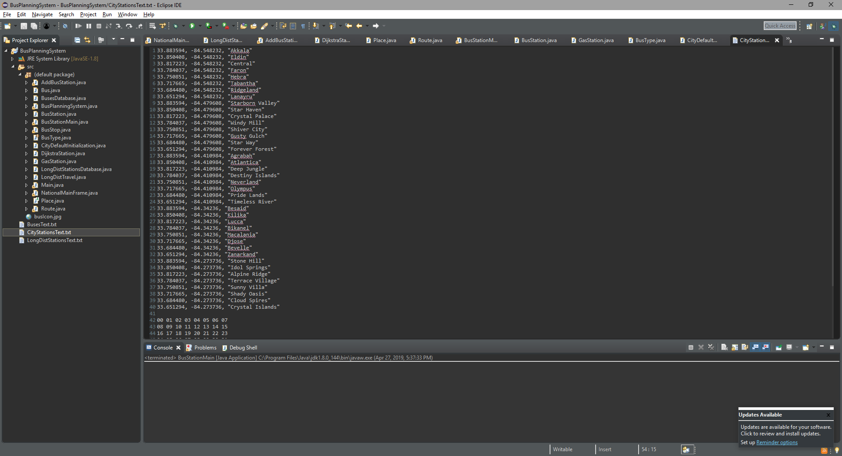

Figure 2.1 – City Stations Database text file

**Displaying the Entire City Station Database Listing**

You can find the entire list of City Stations in the sections labeled “Select Departure Location” and “Select Destination” within the user *interface*. Either of these lists can be sorted by Station name, their *latitude*, or *longitude* (Figure 2.2). Additionally, you can search for a specific station by using the search box found under each list by typing identifying information for the station and pressing the “Enter” key (Figure 2.3).

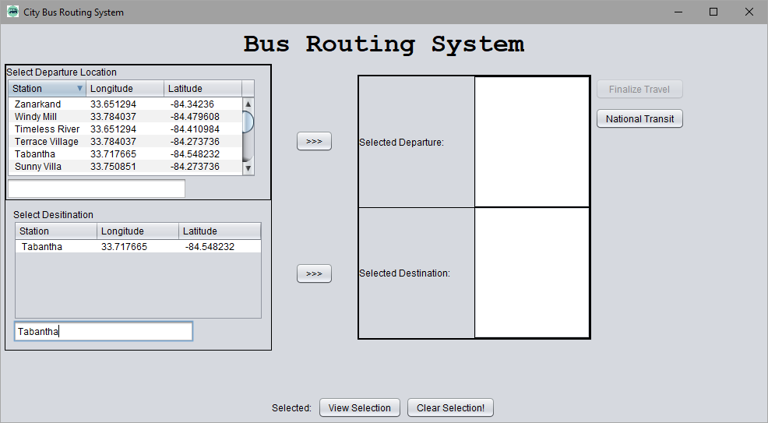

Figure 2.2 – Sorting by station name

Figure 2.3 – Searching for a specific station

Chapter 3

City Route Planning

**CITY ROUTE PLANNING**

**What is a City Route Plan?**

In its simplest sense, a route plan is the physical path by which you intend to get to a specific location from another. On a broader spectrum, a bus route plan also includes factors such as travel time, detours, distance, type of bus, make of the bus, the gas consumption and capacity of the vehicle, and the connections between locations. All of these elements combine to give companies managing buses on a specific route the information they need to identify the bus, the driver of that bus, and their expected route in the event something goes wrong. Within a city, the schedules of buses on their routes are always changing due to unforeseen circumstances, but are nonetheless very important for the movement of people within that crowded space.

Utilized in BP is a very simplified version of what one could expect from a bus route planner for a city. To that end, it provides very basic information regarding travel time, distance, location, and direction for each relevant station.

**Creating A City Route Plan**

Creating a travel plan using BP is very simple. The only requirement to create a route is to have selected two stations to act as your starting station and your destination. This can be done by clicking the station you want to use in either list, then clicking the **“>>>”** buttons to the side of the lists. Once you have done so, you should see both stations in their corresponding sections to the right of the lists, displaying the names of the stations and their *latitude*s and *longitude*s (Figure 3.1).

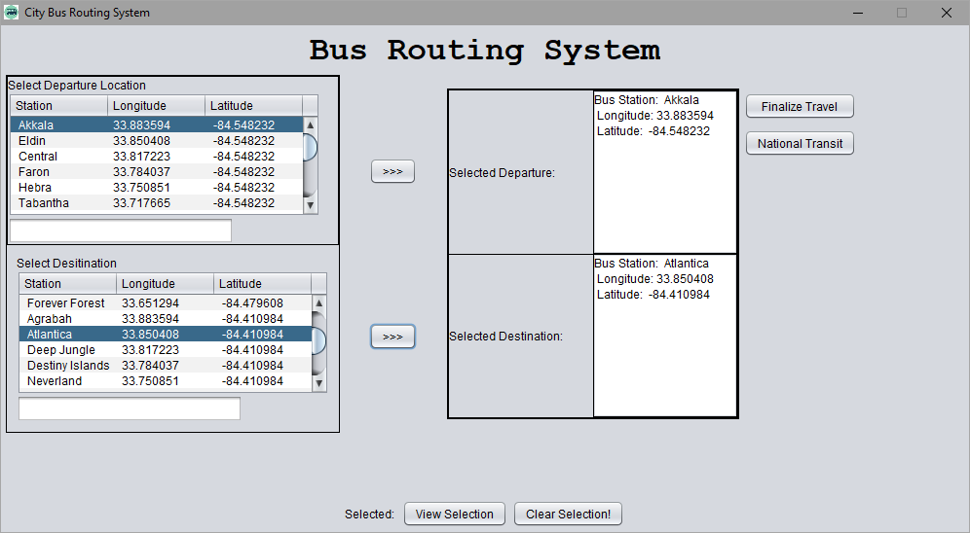

Figure 3.1 – Selecting a departure station and destination

After selecting the two stations you wish to travel between, the **Finalize Travel** button becomes clickable. Clicking on it will open a new window with three options titled **Option A**, **Option B**, and **Option C**, each with a corresponding radio button and **View** button (Figure 3.2). Clicking on the **View** buttons allows you to preview the corresponding route (Figure 3.3). Route A will always exist, but if Route A is more efficient than Route B and Route C, neither will display their own routes and instead say “No alternative found.” You can select your preferred route by clicking on the corresponding radio button and clicking **OK**.

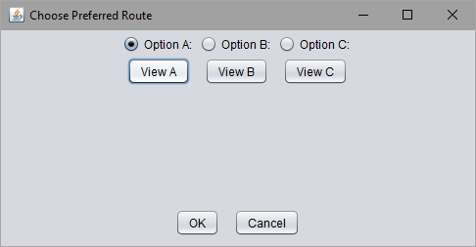 Once your route has been chosen, you can view it again by clicking the **View Selection** button found at the bottom of the main City Bus Routing System window. The information displayed is exactly the same as the information found when you click the **View** buttons in the **Finalize Travel** window (Figure 3.3). Otherwise, you can clear the selection by using the **Clear Selection** button also found at the bottom of the window. This will clear the route you have selected, though it is not necessary for you to be able to select a new route or generate entirely different routes using different stations.

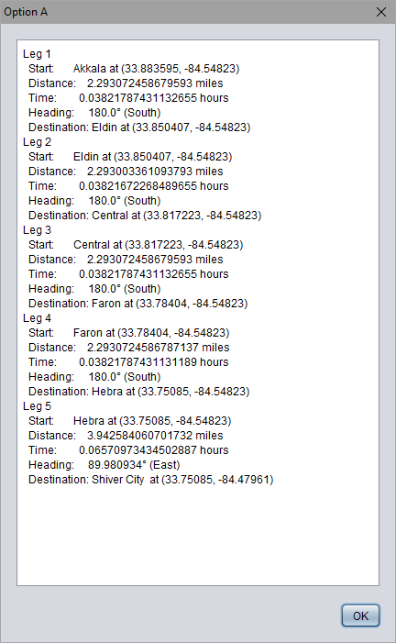

**Understanding Your City Route Plan**

The information displayed in your City Route Plan is simplified version of what one should expect to see in an actual plan. Each leg of the route is shown in sequential order. The first section is titled “Start,” which refers to the station you are traveling from in each leg. It contains information relating to the name and exact location of the station. The next field is titled “Distance” and provides the length of the leg in miles. After that is “Time,” which provides the travel time in hours for each leg. The next line is “Heading,” which shows the direction the bus is going during each leg. Finally, “Destination” is, as the name implies,” the station the bus is traveling to in each leg. Like the “Start” field, it contains the name of the station and its *latitude* and *longitude*. The destination of a leg will always be the starting station of the next leg assuming another leg exists.

Figure 3.3 – Preview route

Figure 3.2 – Finalize travel window

Chapter 4

The National Station Database

**The National Station Database**

**What is the National Station Database?**

The National Station Database is a listing of bus and gas stations found in “LongDistStationsText.txt” (Figure 4.1). At runtime, BP reads the file and compiles a list of bus stations within the *interface* and uses both bus and gas stations while routing between two stations and while performing other calculations. Each station in the *database* is represented by its *latitude* and *longitude*, whether it is a gas or bus station, and the name of the station. The text file is altered when you use the **Add Station** and **Delete Station** buttons. These options are necessary to allow you to create the many stations you will need to generate an efficient route.

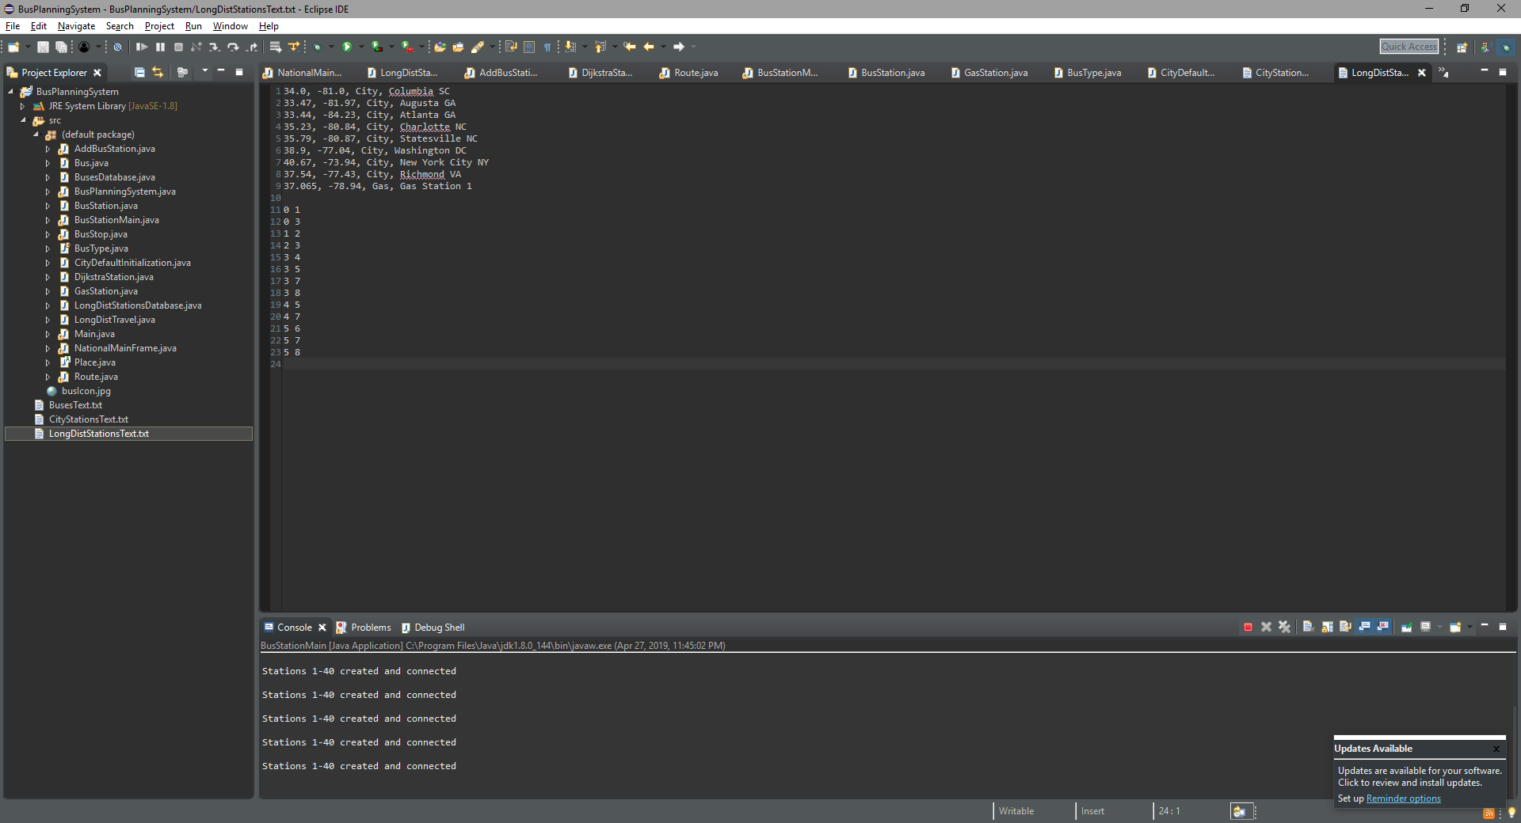

Figure 4.1 – National Station Database

text file

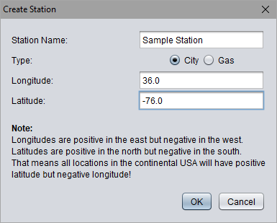**Adding and Deleting Stations**

Adding a new station to the National Station Database is a very simple process for you. The **Add Station** option can be found on the left side of the National Bus Routing System window. Clicking on this option brings up the “Create Station” window (Figure 4.2). In this menu, you will be presented with a field for a station name, whether it is a city bus station or a gas station, and both the *latitude* and *longitude* of the station. Additionally, a note is found at the window to remind you of how to best use *latitude* and *longitude*. Once you have provided all of the information, clicking **OK** will create the station and add it to the *database*. Clicking **Cancel** will return you to the main *interface*.

Keep in mind uniformity while creating your stations. It is recommended to name your bus stations after a city and state and to only use one bus station per city.

Figure 4.2 – Menu to add a new station

Note that created bus stations are unusable in the Nation Bus Routing System until connections have been created. More information can be found in this chapter in the **Adding and Deleting Connections** section.

While the menu provides you with the option of manually creating a gas station, it is not necessary for this system to function. A condition has been added to automatically create and place a gas station when a bus is beginning to run out of fuel. Unlike the bus stations, these stations are automatically connected to the bus stations they are traveling between.

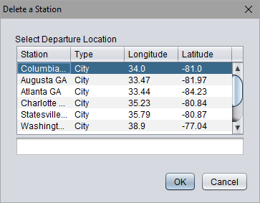

Deleting a station within the *database* is a similarly simple task. Clicking the **Delete Station** button on the left side of the National Bus Routing System window will display the “Delete a Station” window (Figure 4.3). In this menu, you are able to select a bus station from a list. You can sort the list by clicking on the headers of each column as well as search using the text box under the list. Clicking on a station in the list will select it. Clicking **OK** will delete that station from the *database*. Clicking **Cancel** will return you to the main *interface*.

Figure 4.3 – Menu to delete an existing station

**Adding and Deleting Connections**

Adding a connection between two stations is a very straightforward process. Once you have selected a Departure station and a Destination section (Refer to Chapter 6 for additional information), clicking the **Add Connection** button will establish a connecting route between the two stations (Figure 4.4).

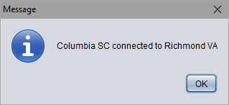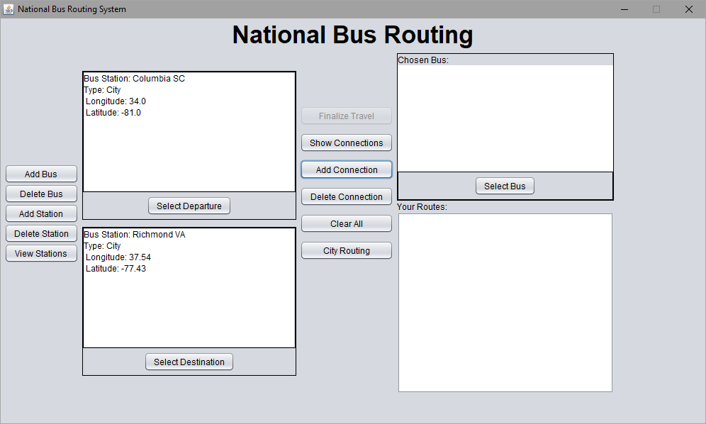

Figure 4.4 – Adding a connection between two stations

The process used to delete a connection is very similar to the process used to create one. Once you have selected a Departure station and a Destination section (Refer to Chapter 6 for additional information), clicking the **Delete Connection** button will delete an existing connecting route between the two stations (Figure 4.5).

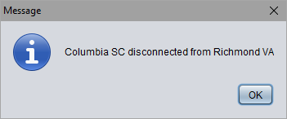

Figure 4.5 – Deleting a connection between two stations

**Displaying the Entire National Station Database Listing**

You can find the entire list of national stations by clicking **View Stations** on the left side of the main user *interface*, at the bottom of the list of buttons. The accompanying window displays a list of all bus and gas stations currently in the *database* (Figure 4.6). The list can be sorted by Station name, their *latitude*, or *longitude* by clicking on the headers of each column. Additionally, you can search for a specific station by using the search box found under each list by typing identifying information for the station and pressing the “Enter” key. Clicking **OK** will close the window and return you to the main user *interface*.

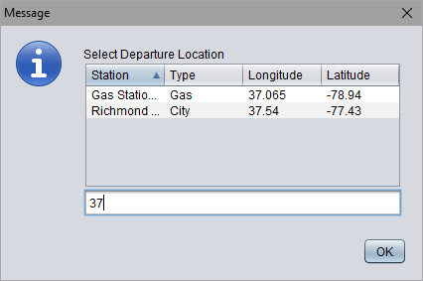

Figure 4.6 – Displaying the full National Station Database Listing

Chapter 5

The Bus Database

**The Bus Database**

**What is the Bus Database?**

The Bus Database is a listing of long-distance buses found in “BusesText.txt” (Figure 5.1). At runtime, BP reads the file and compiles a list of buses within the *interface* and considers all characteristics of the buses while routing between two stations and while performing other calculations. Each bus in the *database* is represented by its make and model, tank size, cruising consumption, and its cruising speed. The text file is altered when you use the **Add Bus** and **Delete Bus** buttons. These options are necessary to allow you to create the many buses you will need to create an efficient routing system.

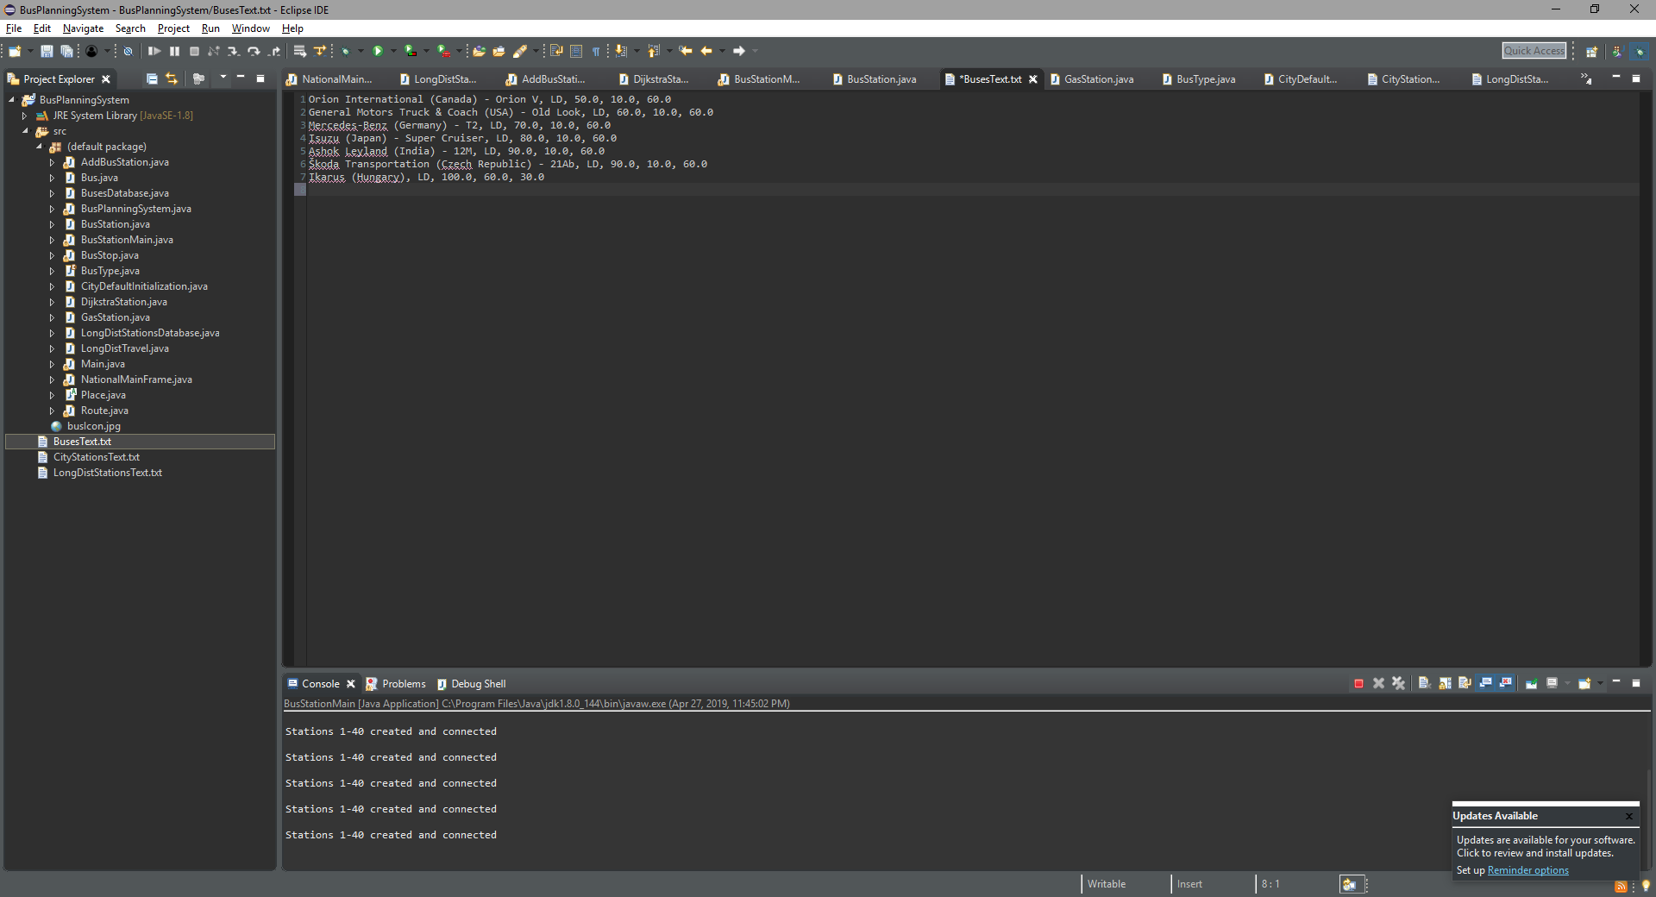

Figure 5.1 – Bus Database text file

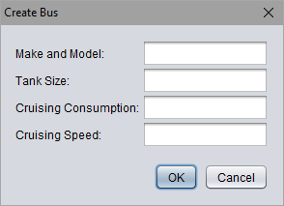**Adding and Deleting Buses**

Adding a new bus to the Bus Database requires very little work on your part to accomplish. The **Add Bus** option can be found on the left side of the National Bus Routing System window. Clicking on this option brings up the “Create Bus” window (Figure 5.2). In this menu, you will be presented with a field for a make and model, the tank size of the bus, the cruising consumption of the bus, and the cruising speed of the bus. Once you have provided all of the information, clicking **OK** will create the station and add it to the *database*. Clicking **Cancel** will return you to the main *interface*.

Figure 5.2 – Menu to add a new bus

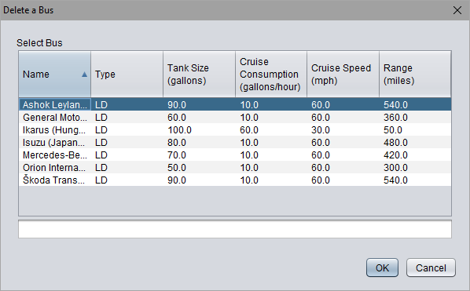 Deleting a bus within the *database* is a similarly simple task. Clicking the **Delete Bus** button on the left side of the National Bus Routing System window will display the “Delete a Bus” window (Figure 5.3). In this menu, you are able to select a bus from a list. You can sort the list by clicking on the headers of each column as well as search using the text box under the list. Clicking on a bus in the list will select it. Clicking **OK** will delete that bus from the *database*. Clicking **Cancel** will return you to the main *interface*.

Figure 5.3 – Menu to delete a bus

**Displaying the Entire Bus Database Listing**

You can find the entire list of buses by clicking **Delete Bus** button on the left side of the main user *interface*, near the top of the list of buttons. The accompanying window displays a list of all buses currently in the *database* (Figure 5.3). The list can be sorted by name, type, tank size, cruise consumption, cruise speed, and range by clicking on the headers of each column. Additionally, you can search for a specific bus by using the search box found under each list by typing identifying information for the bus and pressing the “Enter” key. Clicking **OK** or **Cancel** will close the window and return you to the main user *interface*. Note that since this list is relying on the deletion functionality, the **OK** button has the potential to delete a bus if you have one selected. To avoid this, it is recommended that you use the **Cancel** button if you are only referencing the list.

Chapter 6

National Route Planning

**NATIONAL ROUTE PLANNING**

**What is a National Route Plan?**

In its simplest sense, a route plan is the physical path by which you intend to get to a specific location from another. On a broader spectrum, a bus route plan also includes factors such as travel time, detours, distance, type of bus, make of the bus, the gas consumption and capacity of the vehicle, and the connections between locations. All of these elements combine to give companies managing buses on a specific route the information they need to identify the bus, the driver of that bus, and their expected route in the event something goes wrong. On a national scale, some of the most important factors for buses are their comfort and their fuel efficiency, since companies need to save money, but also need to keep their riders happy for the duration of the trip.

Utilized in BP is a very simplified version of what one could expect from a bus route planner on a national scale. To that end, it provides very basic information regarding travel time, distance, location, and direction for each relevant station, but it also factors in gas consumption, tank size, and cruising speed to account for deviations in the route due to gas stations.

**Creating A National Route Plan**

Creating a national travel plan using BP is very simple. The only requirement to create a route is to have selected two stations to act as your starting station and your destination and a bus to travel on. This can be done by clicking **Select Departure** and clicking the station you want to use as your starting point, then clicking **OK** to close the window and save the selection in the field above the **Select Departure** button. The process to select the destination is much the same. Click the **Select Destination** button and click the station you would like to travel to. Click **OK** to close the window and save the selection in the field above the **Select Destination** button. Next, repeat the process with to select a bus. Click on the **Select Bus** button, click on the bus you would like to use, and click **OK** to save the selection into the field above the **Select Bus** button. Once you have done selected two stations and a bus, each should be visible in their corresponding fields along with their relevant characteristics (Figure 6.1).

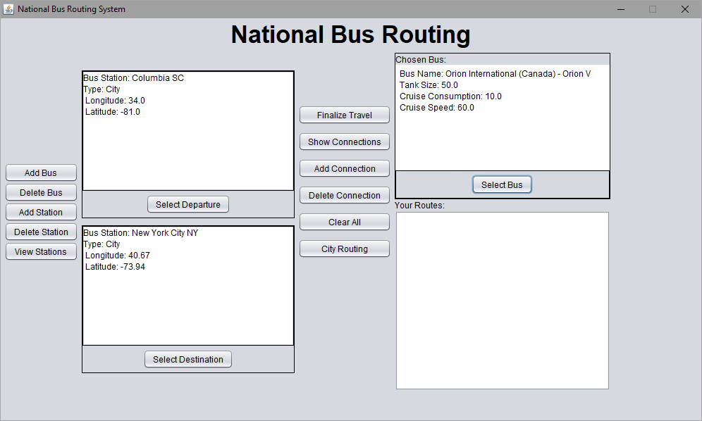

Figure 6.1 – Selection departure and destination stations and a bus

After selecting the two stations you wish to travel between, the **Finalize Travel** button becomes clickable. Clicking on it will open a new window with three options titled **Option A**, **Option B**, and **Option C**, each with a corresponding radio button and **View** button (Figure 6.2). Clicking on the **View** buttons allows you to preview the corresponding route (Figure 6.3). Route A will always exist, but if Route A is more efficient than Route B and Route C, neither will display their own routes and instead say “No alternative found.” You can select your preferred route by clicking on the corresponding radio button and clicking **OK**.

Once your route has been chosen, you can view it again in the bottom right of the main National Bus Routing System window, in the section titled “Your Routes” (Figure 6.3) The information displayed is almost the same as the information found when you click the **View** buttons in the **Finalize Travel** window (Figure 6.4). The difference between the preview and the final route is that the final route includes gas stations when the bus needs gas. Otherwise, you can clear the selection by using the **Clear All** button found next to the final route in the center of the window. This will clear the route you have selected, though it is not necessary for you to be able to select a new route or generate entirely different routes using different stations or buses.

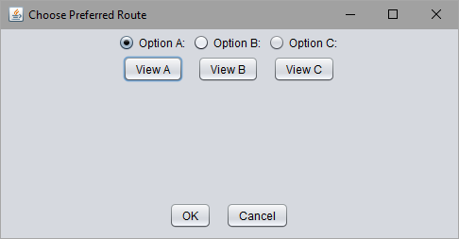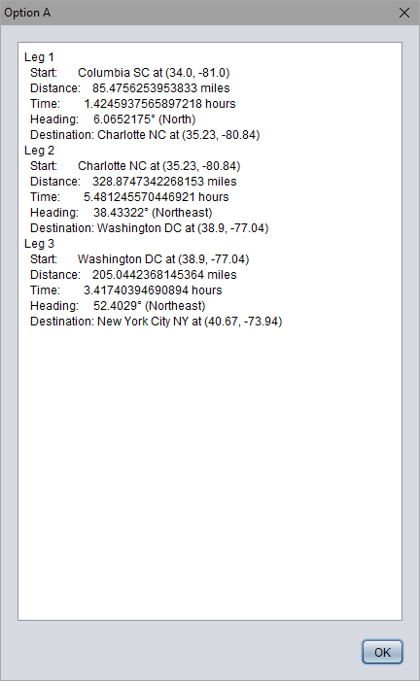

Figure 6.2 – Finalize travel window

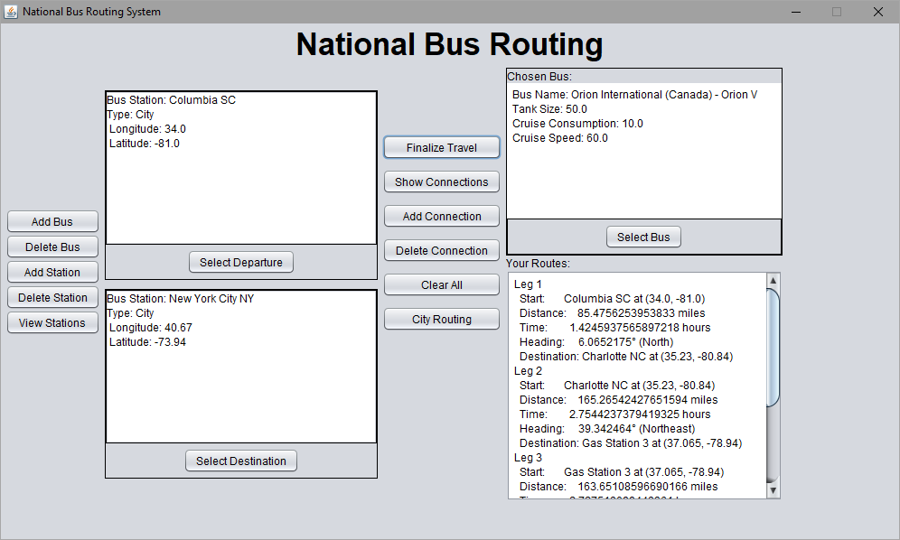

Figure 6.3 – “Your Routes” finalized section

Figure 6.4 – Preview route

**Understanding Your City Route Plan**

The information displayed in your National Route Plan is simplified version of what one should expect to see in an actual plan. Each leg of the route is shown in sequential order. The first section is titled “Start,” which refers to the station you are traveling from in each leg. It contains information relating to the name and exact location of the station. The next field is titled “Distance” and provides the length of the leg in miles. After that is “Time,” which provides the travel time in hours for each leg. The next line is “Heading,” which shows the direction the bus is going during each leg. Finally, “Destination” is, as the name implies,” the station the bus is traveling to in each leg. Like the “Start” field, it contains the name of the station and its *latitude* and *longitude*. The destination of a leg will always be the starting station of the next leg assuming another leg exists. Occasionally, the length of the final route will be longer than the length of the route shown in the preview after clicking the **Finalize Travel** button. This occurs when a gas station is automatically created and placed to allow the bus to continue traveling.

**APPENDIX**

***Sample Buses***

Make & Model: Orion International (Canada) – Orion V

Tank Size: 50.0 GAL

Cruise Consumption: 10.0 GAL/hr

Cruising Speed: 60.0 mph

Make & Model: Mercedes-Bens (Germany) – T2

Tank Size: 70.0 GAL

Cruise Consumption: 10.0 GAL/hr

Cruising Speed: 60.0 mph

Make & Model: Isuzu (Japan) – 12M

Tank Size: 80.0 GAL

Cruise Consumption: 10.0 GAL/hr

Cruising Speed: 60.0 mph

Make & Model: Ikarus (Hungary)

Tank Size: 100.0 GAL

Cruise Consumption: 60.0 GAL/hr

Cruising Speed: 30.0 mph

Make & Model: Škoda Transportation (Czech Republic) - 21Ab

Tank Size: 90.0 GAL

Cruise Consumption: 10.0 GAL/hr

Cruising Speed: 60.0 mph

***Sample Bus Stations***

Station Name: Columbia SC

Type: City

Latitude: -81.0

Longitude: 34.0

Station Name: Atlanta GA

Type: City

Latitude: -84.23

Longitude: 33.44

Station Name: Gas Station 1

Type: Gas

Latitude: -78.94

Longitude: 37.065

Station Name: New York City NY

Type: City

Latitude: -73.94

Longitude: 40.67

Station Name: Washington DC

Type: City

Latitude: -73.94

Longitude: 40.67

**GLOSSARY**

**Database:** A structured set of data. Within the context of BP, it refers to the text files that contain stations, buses, and their identifying characteristics.

**Eclipse:** An integrated development environment used for computer programming. It is widely used for Java.

**Interface:** Within the context of BP, this refers to the windows the user sees and interacts with that simplifies the process of creating a travel plan.

**Java:** A widely used object-oriented programming language. It is the language used in the development of BP.

**Latitude:** The angular distance of a place north or south of the earth's equator.

**Longitude:** The angular distance of a place east or west of the earth’s meridian at Greenwich, England.

**Runtime Environment:** The execution environment provided to an application or software by the operating system.